8.UI Design

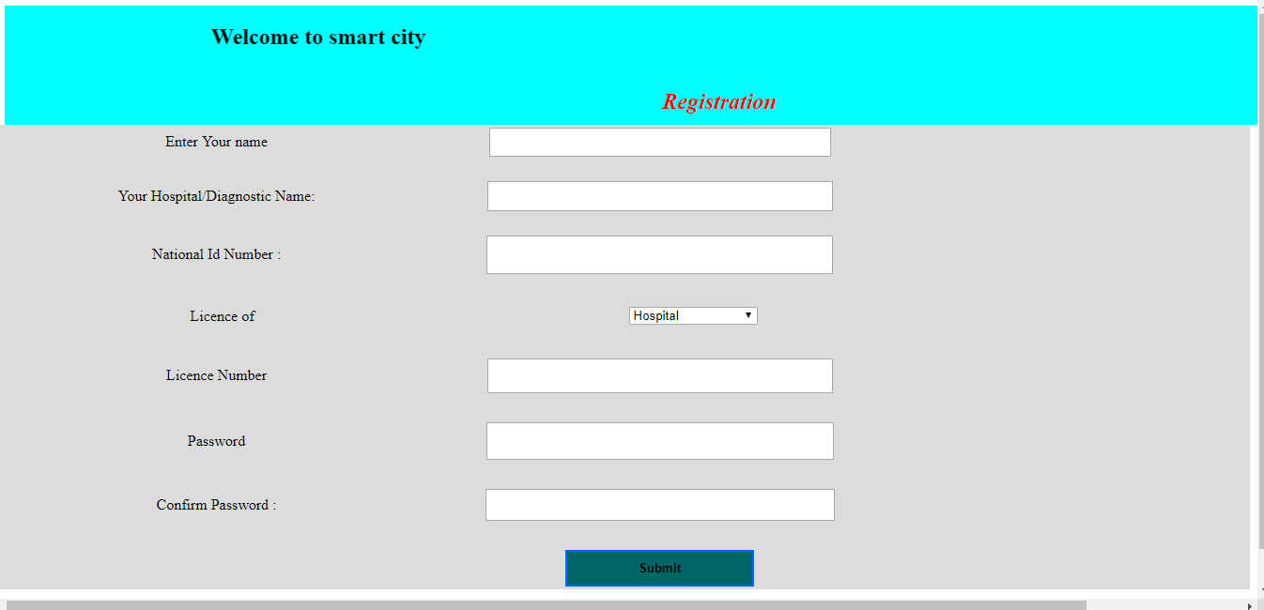

Admin registration on this page.For registration admin need license number of their organization.

After admin registration he/she go to the logion page.

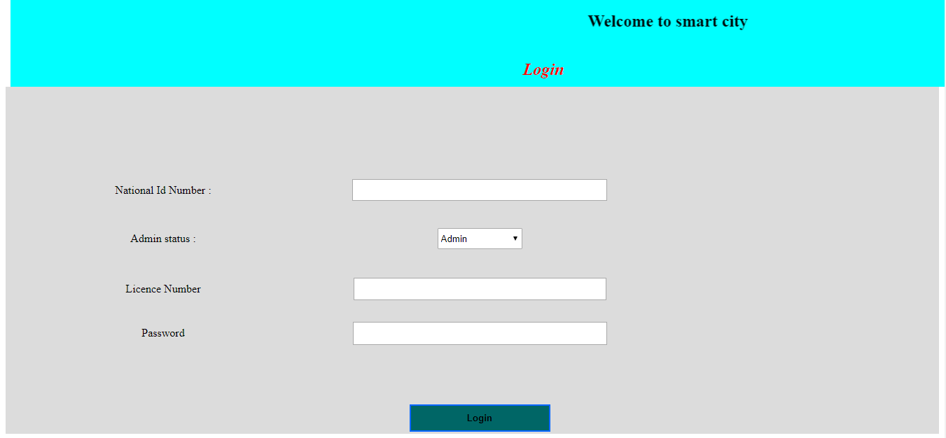

After login the first page is hospital open page. If admin wanted to open his own hospital admin need to fill up all requirement of the page.

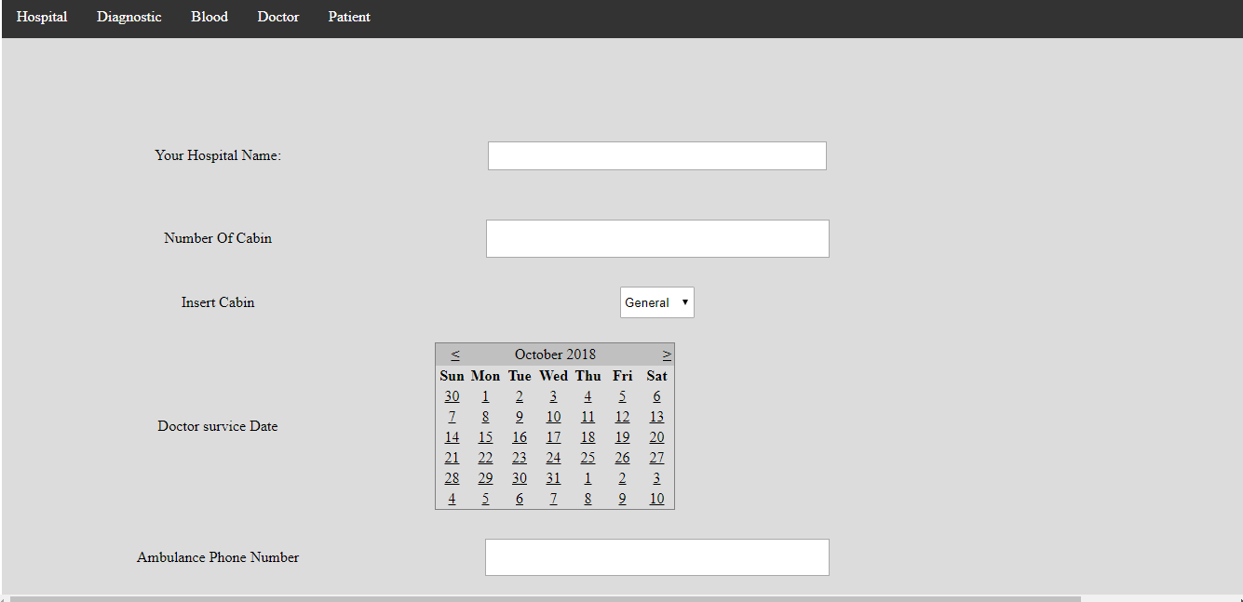

When admin click diagnostic nav bar. He can go to create a diagnostic center. For this he need to fill requirement.

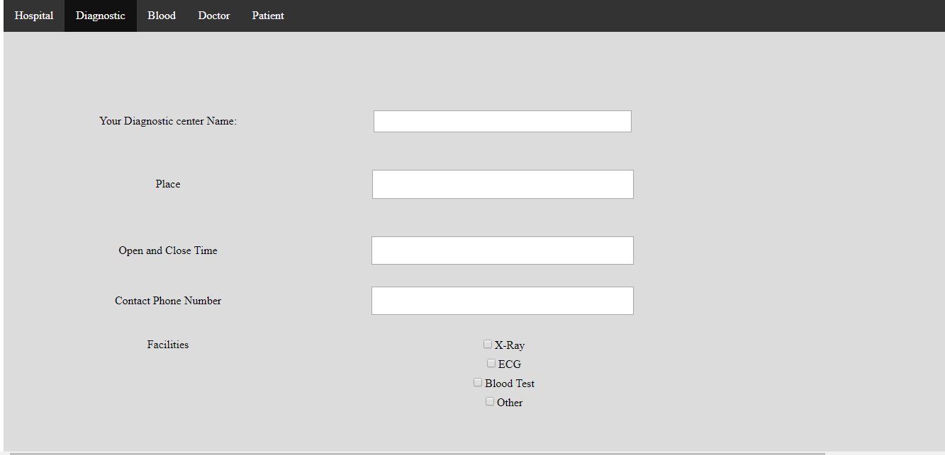

When he click Blood he add his hospital/diagnostic center blood donor.

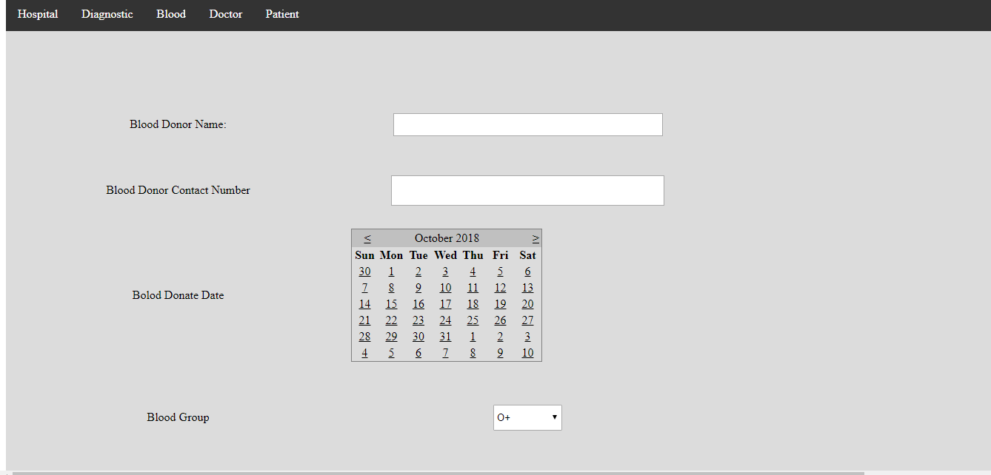

If admin click doctor ,he can sit doctor for his hospital or diagnostic center.

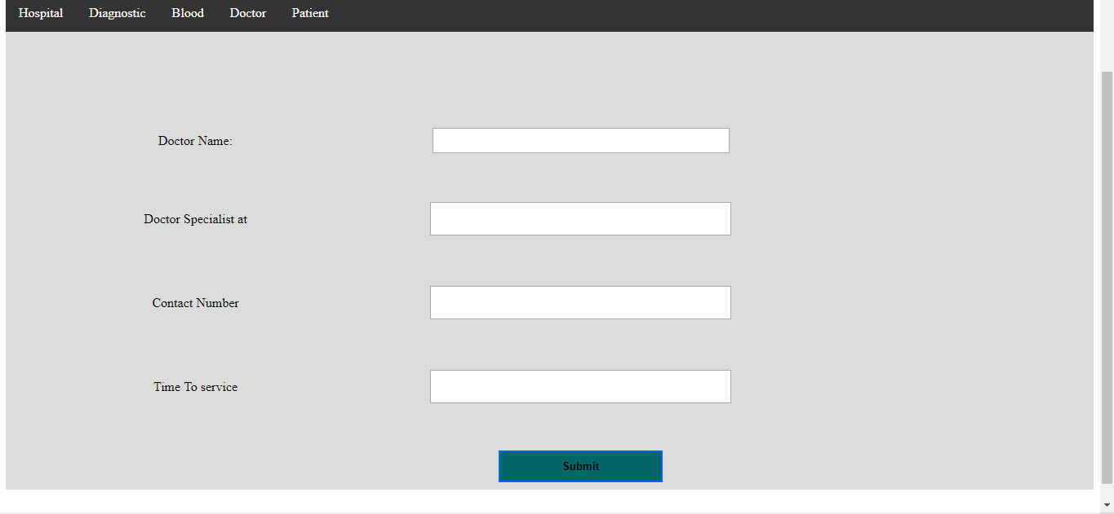

When admin click patient he can show the patient in his hospital or diagnostic.

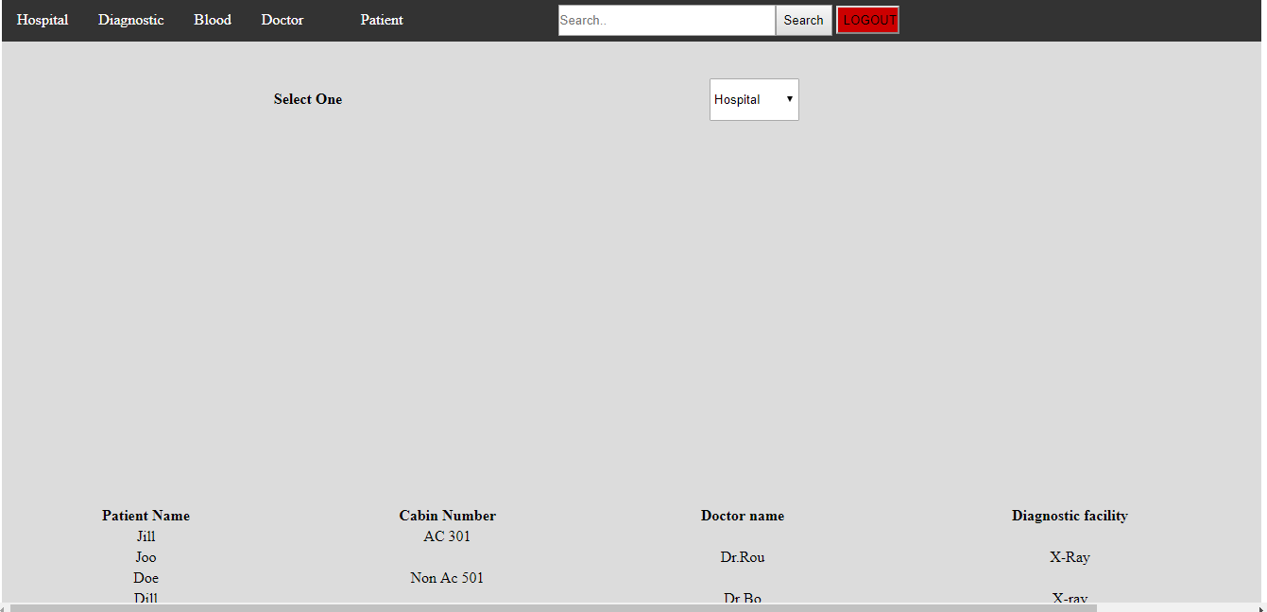

For user when a user go to (user.aspx) page they can know how many hospital/diagnostic center/doctor/blood donor of their smart city. They can search their hospital/diagnostic center/doctor/blood donor of their smart city.

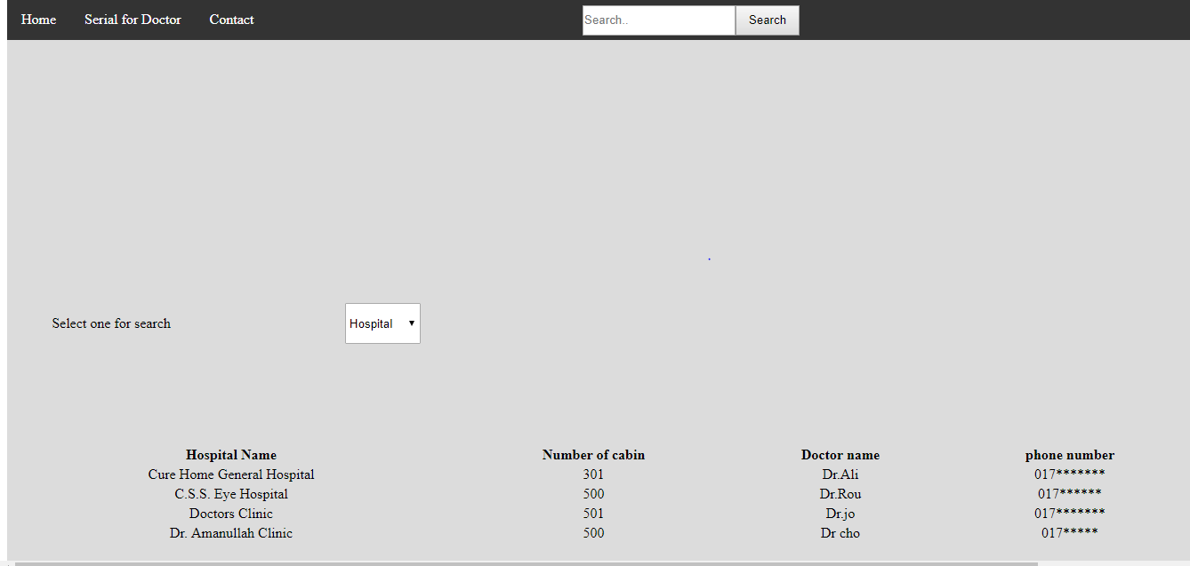

When user click serial for doctor he can serial for their doctor or admit in the hospital or call ambulance.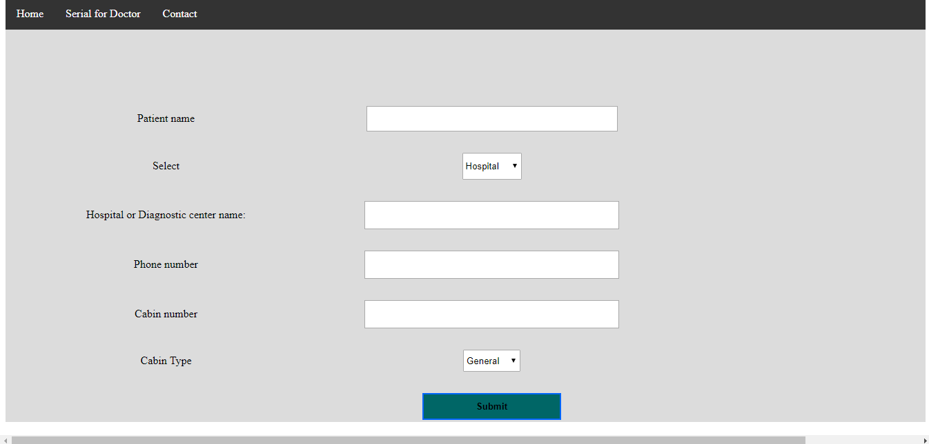

In the contact page they can see all the super admin of the system.